Itinerary
Friday
Registration – All Day 2:30 – 4:00 - Board of Directors Meeting 6:00 – 7:00 – Dinner 7:00 – 8:00 - Speaker Gracia Burnham 9:00 – Until? – Hospitality Room
Saturday

7:00 – 8:00 – Breakfast 8:00 – 11:30 – Open Session 12:00 -1:00 – Lunch 1:00 – 2:00 – Speaker Lindy Kirkland, President ACA 1:00 – 2:00 - President’s Roundtable 3:00 – 5:30 – Free Time 6:00 – 700 – Dinner 7:00 – 8:00 - Speaker Ken Bevel 8:00 – Until? – Hospitality Room
Sunday

8:00 – 9:00 – Breakfast
9:00 – 10:00 - Worship Service Jacques Rancourt

Music throughout the weekend by Stephanie Hockman

2012
Pilots for Christ International
Convention

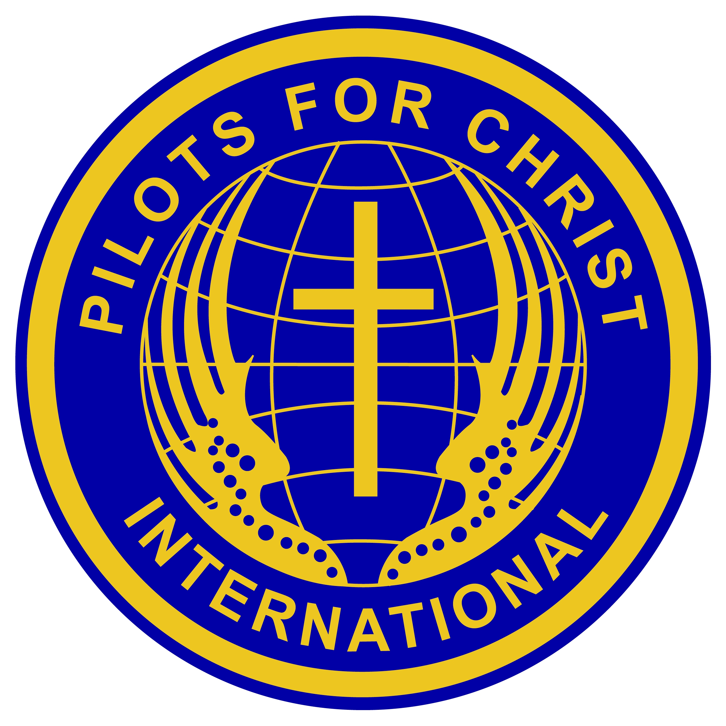

September 7-9
Williamsburg, VA

Gracia Burnham
Gracia Burnham is the widow of Martin Burnham and the mother of Jeff, Mindy and Zach.
For 17 years she and Martin served with New Tribes Mission in the Philippines where Martin was a jungle pilot delivering mail, supplies and encouragement to other missionaries and transporting sick and injured patients to medical facilities. Gracia served in various roles supporting the aviation program and also home-schooled their children--all of which were born in the Philippines.
While celebrating their 18th wedding anniversary at Dos Palmas Resort off Palawan Island, the Burnhams were kidnapped on May 27, 2001, by the Abu Sayyaf Group, a militant group of Muslims. They seized several more guests and took them to Basilan Island, an ASG stronghold.
In the ensuing months some of the hostages were killed, but most were set free. From November 2001, only the Burnhams and one other hostage remained in captivity.
During their 376 days of captivity, they faced near starvation, constant exhaustion, frequent gun battles, coldhearted murder-and intense soul-searching about a God who sometimes seemed to have forgotten them. On June 7, 2002, in a firefight between the Philippine military and the Abu Sayyaf Group, Martin was killed. Gracia was wounded, but was freed.
Since that time Gracia has authored two books, In The Presence Of My Enemies, and To Fly Again. Her oldest son Jeff and his wife Sarah have accepted an assignment with Flying Mission Services in Botswana, Africa. Mindy is married to Andy Hedvall, a "missionary kid" from South America. Gracia resides in Rose Hill, Kansas.

Ken Bevel
Ken Bevel is a native of Jacksonville, Florida and has been a member of Sherwood Baptist Church since February 2007.
After 20 years of active service in the United States Marine Corps, including tours of duty in Iraq and Afghanistan, Ken retired to serve in the ministry. Ken is the Associate Pastor of Assimilation and Events at Sherwood Baptist Church.
In addition to his daily responsibilities, Ken may be recognized by his role as Lieutenant Michael Simmons in the 2008 inspirational movie “Fireproof” and for his role as Nathan Hayes in “Courageous.”
When asked what message did he want people to take away from "Courageous" Ken said, "The message I pray people walk away with is one of hope and the ability to understand “failure is not final.” As fathers and parents, each of us has missed the mark in one way or another. We have provided incorrect advice, scorned our children excessively or crushed their spirits. This is not the end. Our children still need us for encouragement, instruction and for the greatest commodity, love. So our approach should not be as one who withdraws him or herself from their lives. We should be willing to ask for forgiveness and earn their trust through intentionally rebuilding the relationship."
Ken and Lauana have been happily married for 15 years and two children, Kyra and Kaleb.

